THIS “THERAPY” IS FREE… ALMOST.

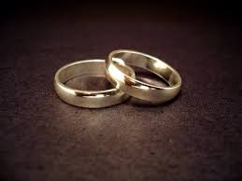

No matter how long you’ve been together, a really good idea is to pay attention to the state of your union. No one likes living in a stale-take-it-for-granted relationship. Even if you rate your marriage as “almost perfect,” the payoff from a little extra awareness can pay off big-time.

So why not include a kick in your pants, MARRIAGE CHECK-UP as part of your yearly physical?

So much has been written about relationship joys and tribulations, including suggestions about how to turn back on some measure of that spark you surely remember. (It’s hard to forget.)

Here’s a few of my favorite self-help LOVE books:
1. The Relationship Cure: A 5 Step Guide to Strengthening Your Marriage, Family, and Friendships by John Gottman and Joan DeClaire
This one is the best. Dr. Gottman has figured out a way to predict divorce with over 90 percent accuracy based on just a few key communication behaviors. In this book, he’s applied those observations — in practical, smart, easy-to-apply lessons.
2. The Seven Principles for Making Marriage Work: A Practical Guide from the Country’s Foremost Relationship Expert by John Gottman
Looking for the perfect wedding, Valentines or gift -to- self? Dr. Gottman’s advice is practical and on the nose. He talks about the small changes which can pay off with giant love-rewards. His ideas mirror my humble opinion that you don’t have to be sick to get better. Every couple deserves to read this book.
3. THE FIVE LOVE LANGUAGES: The Secret To Love That lasts by Gary Chapman
One reviewer explained that this book is a perennial best-seller because it helps you read your partner’s weird mind. The “Five Languages” are like love personalities: 1.words of affirmation 2.acts of service 3.receiving gifts 4.quality time and 5.physical touch. Dr. Chapman helps his readers to understand their own love-needs as well as the sometimes very different needs of their spouse. *Spoiler alert: Those sincere love messages you think you are sending, may not be working to let your partner feel loved.
4.The Art of Loving by Eric Fromme
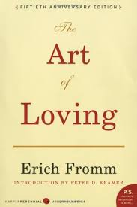
A reminder that there are some things that were thought about before I was born. In the name of LOVE, this is an oldie, worth a read. Wading through the confusion between falling in love and being in love, he describes LOVE as an art which needs to be practiced with concentration and patience. Get: "The Art of Loving" by Erich Fromm

5. Mating In Captivity by Esther Perel

I’m in awe of Esther’s work. She speaks the truth about love and desire. She says, “'When intimacy collapses into fusion, it is not a lack of closeness but too much closeness that impedes desire. Our need for togetherness exists alongside our need for separateness.” Bravo, Esther. We all can learn from her.
Get "Mating in Captivity: Unlocking Erotic Intelligence" by Esther Perel

There are others for sure, but these books are especially good choices to help you and your partner to re-think your commitment and rev things up a bit.

Have other favorites? Please share.

:

